Project Planning Phase

Planning Logic – Employee Raise Issue
The Planning Logic for the Employee Raise Issue project defines the systematic steps required to design, develop, test, and implement the solution in ServiceNow. The plan focuses on making the issue-raising process simple for employees and easy to manage for administrators.
Planning Logic:
- Identify the Problem
Understand the difficulties employees face while reporting workplace or IT-related issues, such as confusion, incomplete information, and difficulty tracking requests.
- Define Project Requirements
Identify the required fields, categories, subcategories, issue states, validations, and user roles needed for the application.
- Create the Data Structure
Create the Employee Raise Issue table and configure the required fields to store employee issue information in a structured manner.
- Develop the Record Producer
Create a Raise Employee Issue Record Producer that allows employees to submit their issues through a simple and guided form.
- Configure Form Logic
Implement mandatory fields, Category–Subcategory dependency, UI Policies, and Client Scripts to improve data accuracy and user experience.
- Integrate with Employee Center/Service Portal
Make the Record Producer accessible through the Employee Center/Service Portal so employees can easily find and use the issue-raising facility.
- Test the Solution
Test form submission, mandatory-field validation, category and subcategory selection, data creation, and different user scenarios to ensure the solution works correctly.
- Manage Submitted Issues
Provide administrators/support teams with centralized access to submitted issues so they can review, track, and manage employee concerns.
- Plan for Future Enhancement
The application can later be enhanced with automated notifications, workflows, approvals, SLA tracking, reports, dashboards, and integrations.
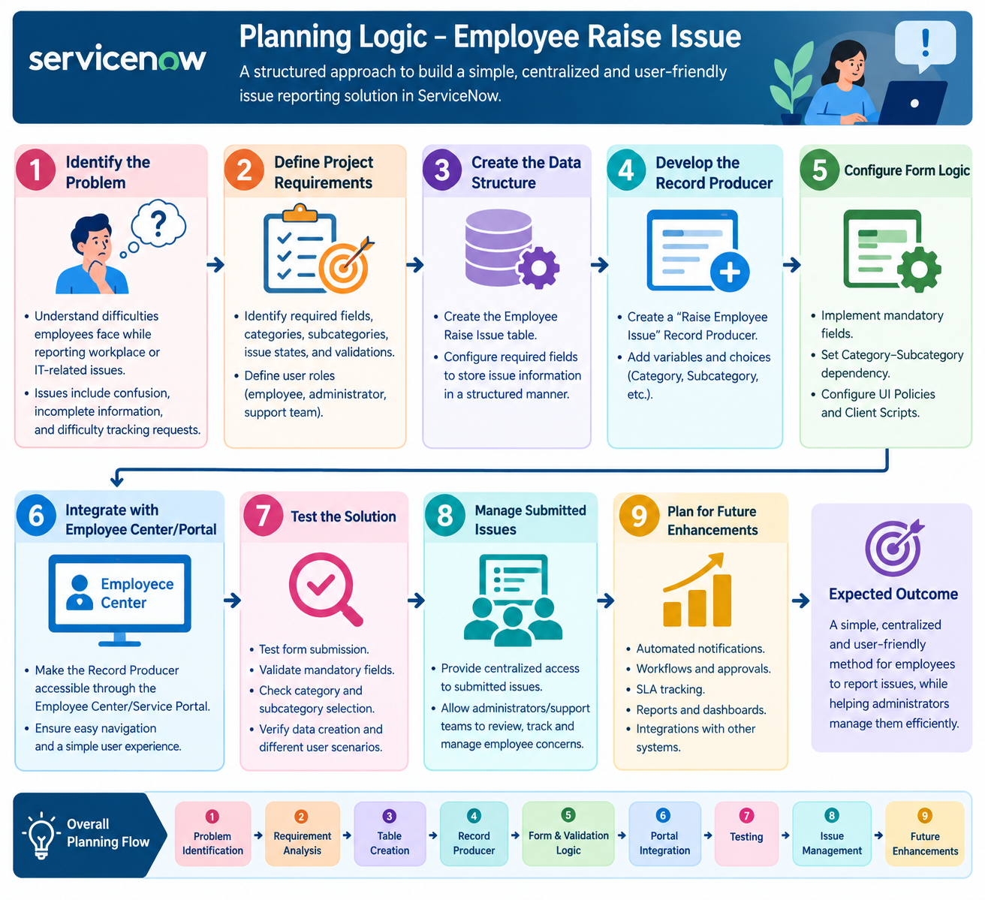
Expected Outcome:
The planning logic ensures that the Employee Raise Issue application is developed in a structured way and provides employees with a simple, centralized, and user-friendly method to report issues, while helping administrators manage those issues efficiently.

